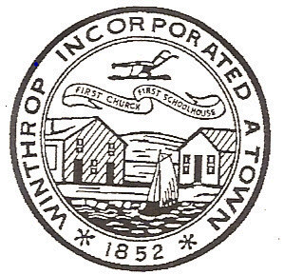

January 2, 2008

Town Council Meeting
Under the Rules and Procedures of the Winthrop Town Council, President Reilly called the meeting to order at 7:30 PM in the Cummings School Multipurpose Room. Councilor Calla, Councilor Ferrino, Councilor Gill, Councilor Letterie, Councilor DelVento, Councilor Maggio, Councilor Sanford, Vice President Boncore and President Reilly were present.He stated the purpose of this Special Meeting was to elect a Vice President per the Charter. He asked if there were any Motions on the floor.

Motion: by Councilor Calla to nominate Councilor Boncore.
2nd by Councilor Maggio.

President Reilly asked if there was any discussion on the Motion.

Voice Vote: to elect Councilor Boncore as Vice President.

Councilor Sanford asked that the Council award Citations to the Recipients of the Winthrop Chamber of Commerce Awards at the Banquet being held on January 25, 2008 at the Hyatt Harborside.

Motion by Councilor Sanford
2nd by Councilor Calla

Voice Vote: to create Citations to the Recipients of the Winthrop Chamber of Commerce Awards.

Vice President Boncore stated that their would be a Meeting of the Rules & Ordinance Committee on January 8th at 6:30 to finalize the Council Rules.

Motion made by Councilor DelVento
2nd by Vice President Boncore

Voice Vote: to adjourn at approximately 7:40PM.

Respectfully Submitted,

